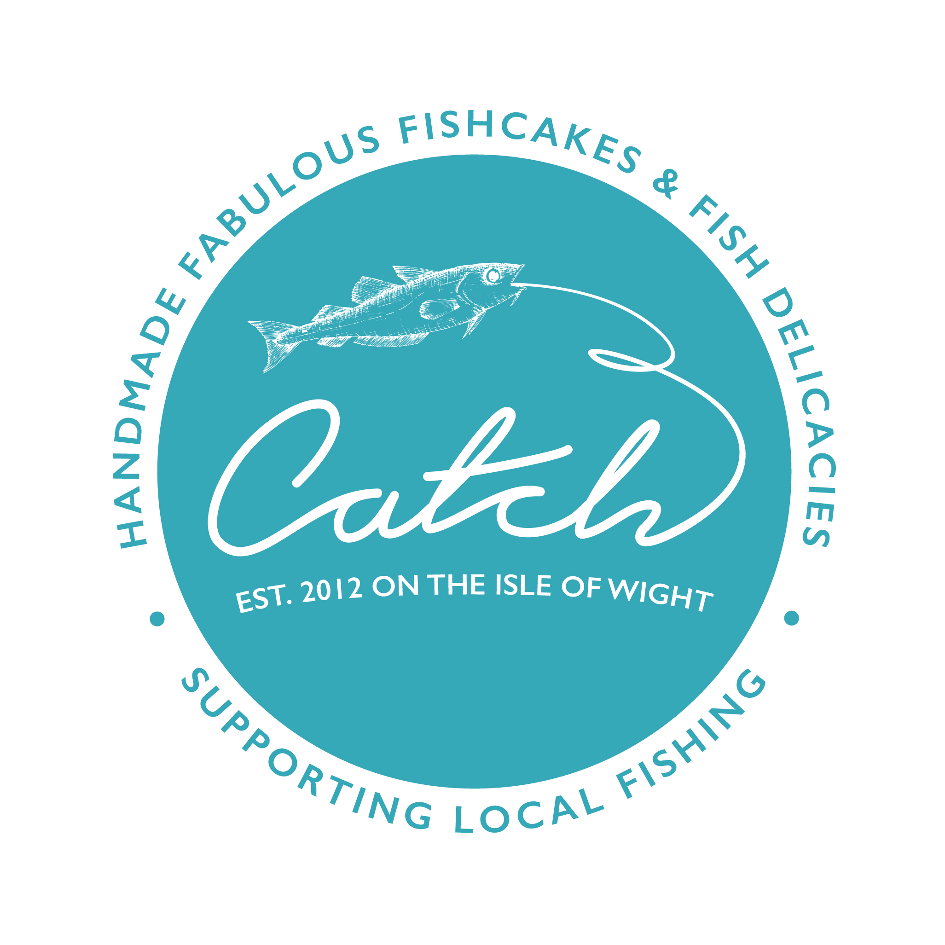
1 June 2020

Welcome to our new bi-weekly FRIDAY delivery service to help our local community and customers at this difficult lockdown time.

​How to order
Have a read of our amazing product menu below and email us you order in the order form format below to ahoy@catchfabulousfishcakes.co.uk

Please email your order over, no later than 5pm on TUESDAY 2 June for FRIDAY 5th June delivery.

This week’s menu has all the fishcakes available. Where fresh stock is unavailable, we will supply the same product frozen. The lobsters were a huge success so after many requests they are on the menu again, along with the Salmon Supreme. Keeping everything lovely and summery for you. At the time of writing we do not know the market price of the lobsters. The price will be confirmed on ordering, but please assume it will be similar to last time - £22 for a half and £40 for a whole. We dare not remove fish soup right now, I think we are giving you a taste of a holiday in France that may have to wait until 2021….

The Crabbie delight this week is Crabbie Tarts – quiche for grown-ups.

The feedback from mackerel fillets is that the beetroot remoulade is enough for 2 portions, so an extra fillet has been added for a light lunch / starter for 2 people.

Local Watercress is still abundant, so fishcake specials are Salmon & Hampshire Watercress.

We still have the same veggies and Jersey Royal potato salad for you. Anyone like any strawberries? Let us know.

Please have your orders in by 5pm on Tuesday. Fill in the attached Menu form with all you details, or simply email over your choices. If you have not ordered from us before, please make sure your full address, postcode and telephone numbers are included. We will call on Thursday to take payment. We cannot give a time for delivery on Friday, I am sorry, but the route is not planned until Thursday afternoon. We will not leave fresh products on your doorstep if you are not in – lobster will not take kindly to the heat!!

At the bottom of this document is the order grid. If you can please copy it onto your email as your order form, it would make it much more straightforward for us to compile. Please have your order emailed over no later than 5pm ON TUESDAY. Please do not call us as we are in the kitchen during the day, busily making more lovely fishcakes.

Payments are taken by phone before delivery. We will endeavour to acknowledge your email order. That means you are on the system for delivery. Please give any additional delivery instructions at this point – eg ‘box in porch’, confirm address etc. The order will be delivered on Friday. We cannot be time specific I’m afraid.

Delivery is free for orders of £30 or more. For orders of less than £30 a small delivery charge of £5.00 is applied. These delivery prices are only for Milford, Lymington & our local area.

We hope you have been looking forward to this week’s Fishy Friday. Feel free to pass on this email to friends and other people in the local community who may like to join in.

Scroll down for the menu and order grid, which drops into page 3

Catch - Local Delivery Order Sheet
Week Commencing: | 01/06/20
Delivery Date: | 05/06/20
Product | Number of units | Pack size |  | Price per unit
Wightcake |  | Box of 4 |  | £6.00
Gluten Free Wightcake |  | Box of 4 |  | £7.00
Smokey Bill |  | Box of 4 |  | £6.00
Colonial |  | Box of 4 |  | £6.00
Crabbie |  | Box of 4 |  | £7.00
Mac n Beet |  | Box of 4 |  | £6.00
Mac n Hari |  | Box of 4 |  | £6.00
Fishy Fingers |  | 180gms |  | £7.00
Tantalising Tartare Sauce |  | 125ml |  | £2.00
Weekly Fishcake Special:
Salmon & Hampshire Watercress |  | Box of 4 |  | £6.00
Sweet Chilli Salmon |  | Box of 4 |  | £6.00
Weekly Meal Specials: | NA
Soupe de Possion with rouille & cheese crouton |  | 2 serving pot |  | £8.00
Crabbie Tart |  | 1 portion |  | £6.00
Fresh Smoked Mackerel Fillets & Beetroot remoulade |  | 2 fillets |  | £7.00
1/2 Dressed Local Lobster, marie-rose Sauce, summer salad. |  |  |  | TBC
Whole Dressed Lobster, Rose-marie Sauce, summer salad. |  |  |  | TBC
Cold poached salmon supreme with summer salads, herby mayonnaise, & Jersey Royal potato salad |  | 1 portion |  | £11.00
Jersey Royal Potato Salad |  | 1 portion |  | £3.50
Smoked Mackerel Pate |  | 125ml |  | £3.50
Bunched Hampshire Watercress |  |  |  | £2.00
Local Asparagus |  |  |  | TBC
Name:
Address:
Telephone Numbers:
Email:

